Activity 2
- Because we haven’t gone through any code examples or exercises in class, I have no direction as to how to implement this move generator.
2a)
Smoke | Fire | Smoke ⇒ Fire
True | True | True
True | False | False
False | True | True
False | False | True

The sentence “Smoke ⇒ Fire” is not valid because there is one model where the sentence is false. It is not unsatisfiable because it is true for at least one model.

2b)
((Smoke ∧ Heat) ⇒ Fire) ⇔ ((Smoke ⇒ Fire) ∨ (Heat ⇒ Fire))
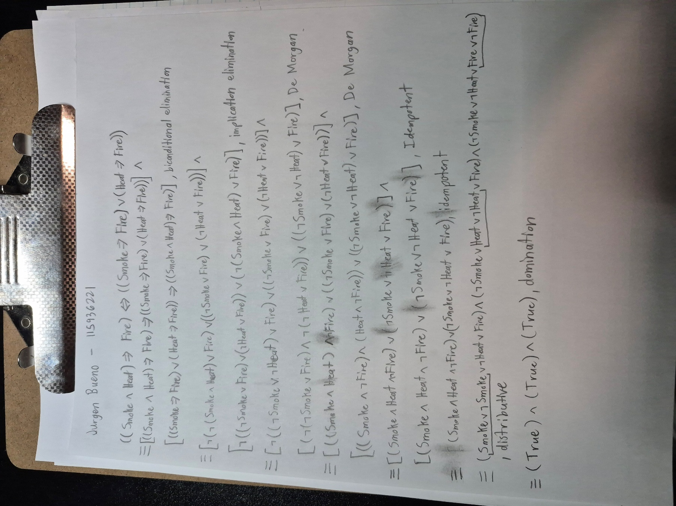
The sentence is valid and not unsatisfiable because it is true for all models.
3a)
A | B | C | D | B∨C
True | True | True | True | True
True | True | True | False | True
True | True | False | True | True
True | True | False | False | True
True | False | True | True | True
True | False | True | False | True
True | False | False | True | False
True | False | False | False | False
False | True | True | True | True
False | True | True | False | True
False | True | False | True | True
False | True | False | False | True
False | False | True | True | True
False | False | True | False | True
False | False | False | True | False
False | False | False | False | False

12 rows result in True, so the sentence B∨C has 12 models.

3b)
A | B | C | D | ¬B | A ⇒ B | (A ⇒ B) ∧ A ∧ ¬B ∧ C ∧ D
True | True | True | True | False | True | False
True | True | True | False | False | True | False
True | True | False | True | False | True | False
True | True | False | False | False | True | False
True | False | True | True | True | False | False
True | False | True | False | True | False | False
True | False | False | True | True | False | False
True | False | False | False | True | False | False
False | True | True | True | False | True | False
False | True | True | False | False | True | False
False | True | False | True | False | True | False
False | True | False | False | False | True | False
False | False | True | True | True | True | False
False | False | True | False | True | True | False
False | False | False | True | True | True | False
False | False | False | False | True | True | False

The sentence has no rows that result in True, so it has no models.
4a)
Food | Drinks | Party | (Food ⇒ Party) | (Drinks ⇒ Party) | [(Food ⇒ Party) ∨ (Drinks ⇒ Party)] | (Food ∧ Drinks) | [(Food ∧ Drinks) ⇒ Party] | [(Food ⇒ Party) ∨ (Drinks ⇒ Party)] ⇒ [(Food ∧ Drinks) ⇒ Party]
True | True | True | True | True | True | True | True | True
True | True | False | False | False | False | True | False | True
True | False | True | True | True | True | False | True | True
True | False | False | False | True | True | False | True | True
False | True | True | True | True | True | False | True | True
False | True | False | True | False | True | False | True | True
False | False | True | True | True | True | False | True | True
False | False | False | True | True | True | False | True | True

All rows result in True, so the sentence is valid.
4b)
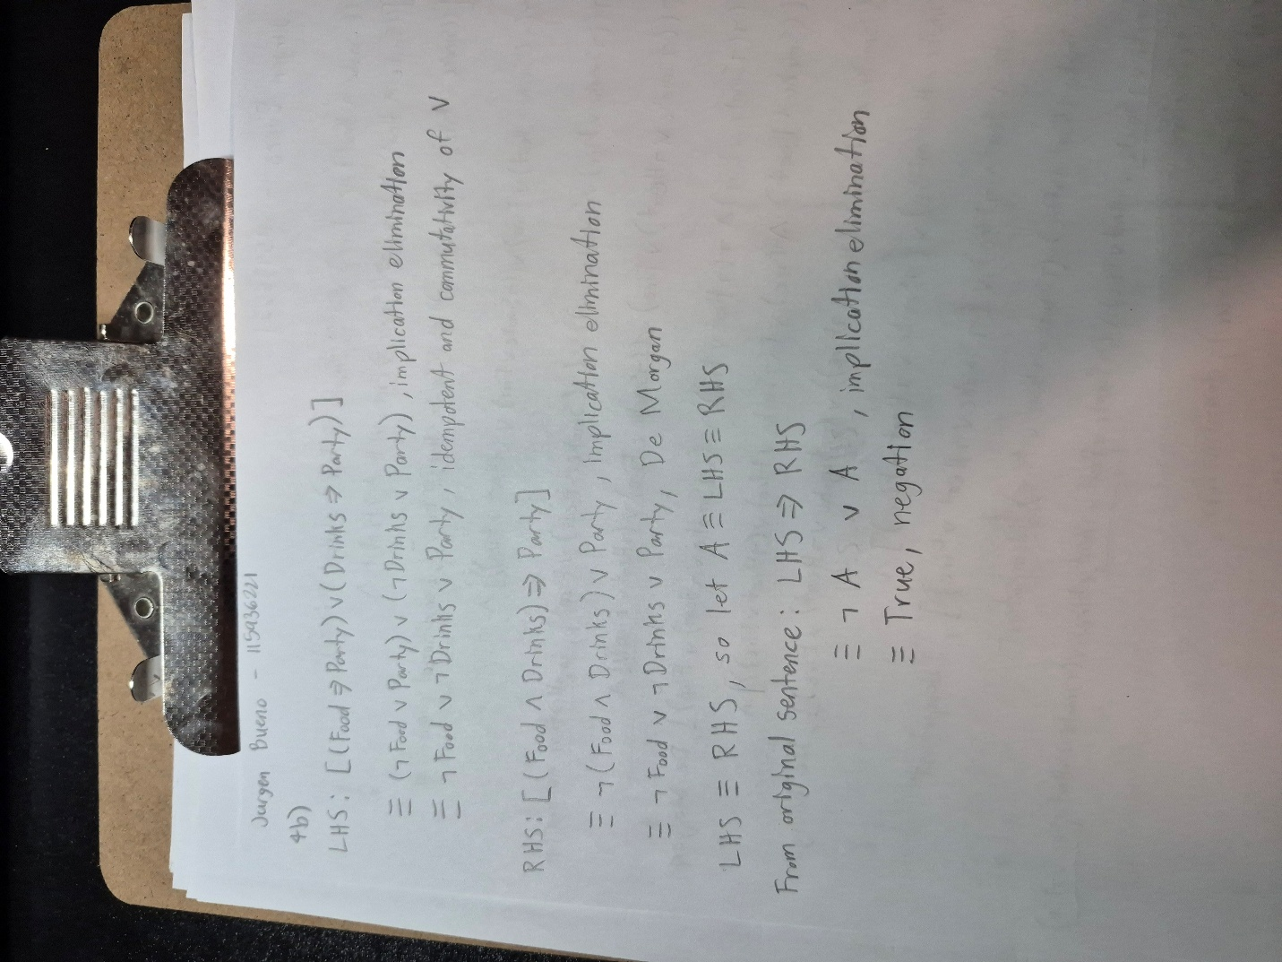
Using CNFs, the original sentence evaluates to True. This confirms my answer from 4a) which shows that the sentence is always True and therefore valid.
4c)
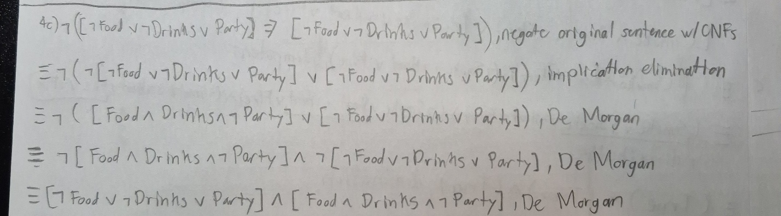
Step | Formula | Derivation
1 | ¬Food ∨ ¬Drinks ∨ Party | Given
2 | Food | Given
3 | Drinks | Given
4 | ¬Party | Given
5 | ¬Drinks ∨ Party | 1, 2
6 | Party | 3, 5
7 | False | 4, 6

Negating the original sentence results in a contradiction, so by resolution, the original sentence is valid.

